ABSTRACT

Power electronic circuits (PECs) are the replacement of carburetor, spark plug etc. of a combustion engine that bring pace in the achievement of green energy revolution. Electric vehicles (EVs) have become an icon of choice in automotive industry. An integral part of any modern-day EV is PECs comprising of DC-AC inverters and DC-DC converters. A DC-AC inverter supplies the high-power electric motor and utility loads such as air-conditioning system, whereas a DC-DC converter supplies conventional low-power, low-voltage loads. However, the need for high power bidirectional DC- DC converters in future electric vehicles has led to the development of many new topologies of DC-DC converters. The H-bridge converter can be used as a DC-DC converter. In this study, a model of H-bridge PEC is devised that can operate a motor in both open loop and feedback methods with a view to regulating speed and torque. It comprises of a non-conventional freewheeling diode placement that ensures the continuity of current through motor when it is cut off from the supply. This topology comes into play when the main supply is unwilling to accept current and hence an auxiliary low voltage source can be charged up instead. Also a graphical user interface (GUI) application is prepared using MATLAB® that forms the foundation of remote control.

Keywords: H-bridge converter drive, Pulse width modulation (PWM), freewheeling diode, Proportional-Integral-Derivative (PID) controller.

CONTENTS
List of Tables and Figures …………………………………………………………..
Acknowledgements ……………………………………………………………………
1. Introduction ………………………………………………………………………..
1.1. Motor speed and torque control……………………………………………
1.2. PID controller in closed loop operation …………………………………..
2. Methodology ……………………………………………………………………….
2.1. Pretesting apparatus ………………………………………………………
2.2. GUI development …..…………………………………………………….
2.3. PWM signal generation …………………………… ……………………
2.4. PID parameter tuning ……………………………………………………
3. Model Description ………………………………..……………………………….
3.1. Model construction ……………………………………………………….
3.2. Model operation ………………………………………………………….
4. Results ……………………………………………………………………………..
4.1. Open loop control outcomes ……………………………………………..
4.2. Closed loop control outcomes ……………………………………………
4.3. Calibration figures in a nutshell …………………………………………..
5. Conclusions …………………………………………………………………………
6. References …………………………………………………………………………..
7. Appendix ……………………………………………………………………………
List of Tables and Figures

Table 1
Table 2
Table 3
Figure 1
Figure 2
Figure 3
Figure 4
Figure 5

Acknowledgements

The completion of this project would not have been possible without the support and supervision of our professor Dr. Md. Habibullah and lecturer Md. Sajjad Hossain. We are highly indebted to them. Our thanks and appreciations also go to Monirul Islam of analog electronics laboratory for his assistance. Thanks to all other people who have willingly helped us out with their abilities.

1. INTRODUCTION

As the focus in vehicular technology shift toward replacing more and more mechanical, hydraulic, or pneumatic systems by electrical systems, power electronic circuits (PECs) have gained a lot of importance in the last decade [1]. Increasing vehicular loads such as utility, entertainment, luxury, and safety loads have increased the demand for efficient PECs. H-bridge DC-DC converter is a PEC that has the functionality of driving DC motors. This converter’s voltage gain can be controlled by means of PWM signal. Also, motor can be run in both directions. Four quadrant operation is possible using this converter. However, regenerative braking feature is not included in the project and so, first and third quadrant operation is made.
H-bridge converter motor drive has the configuration resembling the letter “H,” with the motor located in the center and four switches (transistors or MOSFETs) arranged around it [2]. By controlling these switches, the H-bridge can effectively reverse the direction of the motor and adjust its speed and torque output [2]. In an electric vehicle (EV), for acceleration speed of motor is to be increased and vice versa while braking. Moreover, a vehicle’s load can be increased or decreased. Torque output of motor is thus required to be handled.
In this project a microcontroller-controlled H-bridge driver is modelled with MOSFETs as switches.
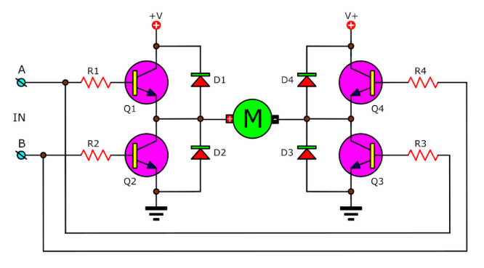
Figure 1: H-bridge DC motor drive [3]
Freewheeling or flyback diodes D1, D2, D3, D4 (Figure 1)are used in motor drive that prevent the high voltage over the switch across the inductive load terminals. This diode is used to protect the circuit from unusual damage due to the sudden decrease in the flow of current in the circuit. When all transistors Q1, Q2, Q3 and Q4 are off (Figure 1), the diodes fly back the energy stored in the inductor by a short circuit path in the main power supply. If the main power is unable to receive the power, then the energy can be fed back to an alternative low power source. The project didn’t use the alternative source however due to unavailability, but a resistor was used for power dissipation which is although an inefficient approach, but handy for installing the alternative source with a separate DC-DC converter.
1.1. Motor Speed and Torque Control
Speed of a permanent magnet (PM) motor can be controlled by varying armature resistance. This is equivalent to controlling the supply voltage across motor terminals. If resistance is used, a portion of energy will be lost at the resistor. An alternative way is to put a variable DC source across motor terminals and can be materialized with a constant DC source and a DC-DC converter like H-bridge.
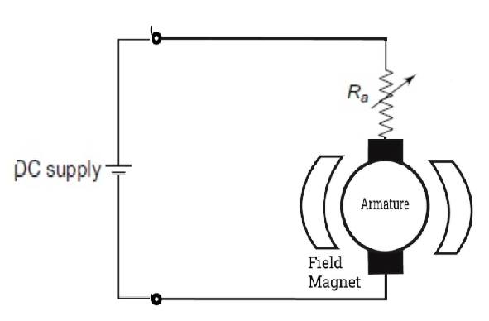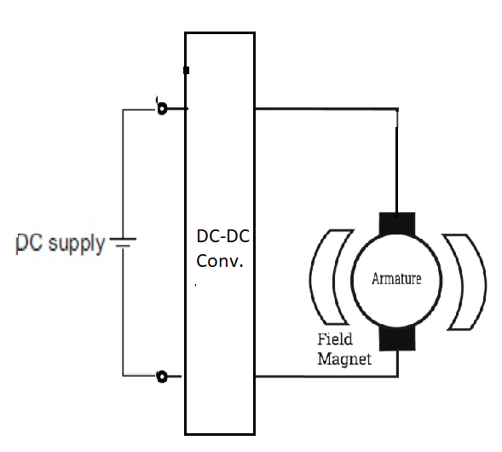
(a) (b)
Figure 2: (a) DC motor speed control by varying armature resististance and (b) by using a DC-DC converter

Speed of DC motor is regulated by the following equation:
$$Speeed=K_{s}×\frac{V- I_{a}R_{a}}{ϕ } (in rpm) (1)$$
Here, V = terminal voltage, I_{a} = armature current, R_{a} = armature resistance, $ϕ$ = field flux and K_{s} is speed constant that depends on motor design [4]. For a PM motor, $ϕ$ is constant and the numerator V - I_{a}R_{a} can be varied by either changing R_{a} or V. In case of H-bridge converter drive, V is varied by regulating pulse width modulated (PWM) signal supplied to the gate of MOSFETs.
Torque of a PM DC motor is,
$$T=\frac{60×E_{b}I_{a} }{2π×speed} (in Nm) (2)$$

Here, E_{b} = back emf and it depends on supplied voltage. For fixed speed rotation under variable torque, E_{b} is to be kept constant under variable armature current that is related proportionally to torque [4]. To keep E_{b} constant it is necessary to regulate supply voltage as per torque demand.
1.2. PID Controller in Closed Loop Operation:
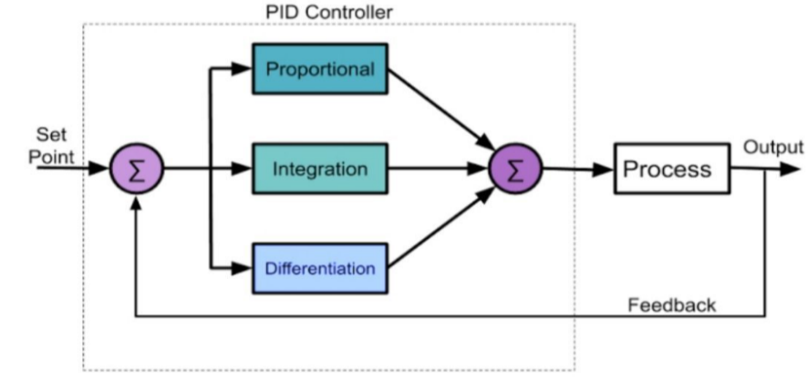
Figure 3: Block diagram of PID controller [5]
To control the speed of motor via feedback process a PID controller helps in many aspects. It monitors the speed (output variable as per Figure 3) of motor (the process according to Figure 3) and corrects any deviation from the set point speed via feedback.
2. METHODOLOGY
This project has travelled through many checkpoints. Checkpoints are summarized below in the flow chart:
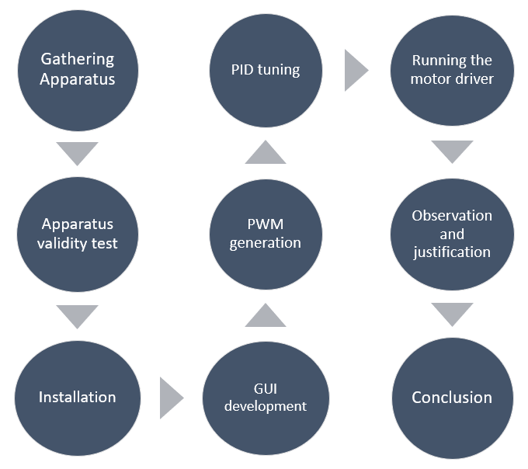
Figure 4: Project flow chart

H-bridge motor drive, designed in the project, is transistor controlled. Atmega microcontroller embedded on Arduino development board can generate PWM signal that triggers a MOSFET. The n-type MOSFET used in the model reaches saturation state with a gate-source voltage (V_{GS}) of 10 V. But Arduino system has the ability to supply 5 V maximum. So, Arduino is incapable to drive the H-bridge. More importantly, this attempt doesn’t isolate power electronic H-bridge circuit from microcontroller. Thus, if there was any fracture in H-bridge circuit, the microcontroller will be affected. Here comes the necessity of MOSFET driver. This driver does the job of isolation.
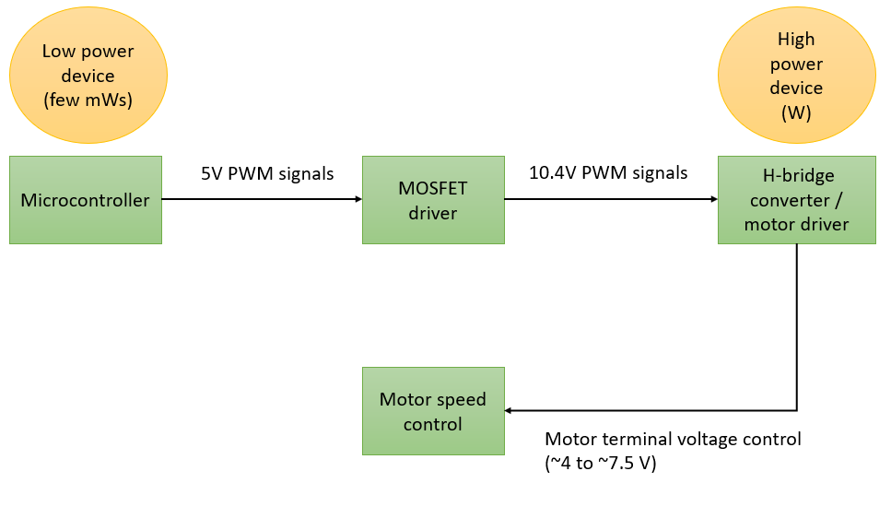
Figure 5: Execution steps to motor drive modelled for EV
2.1. Pretesting apparatus:
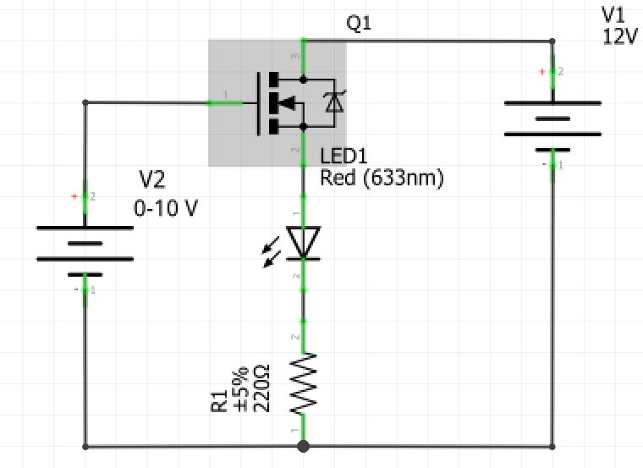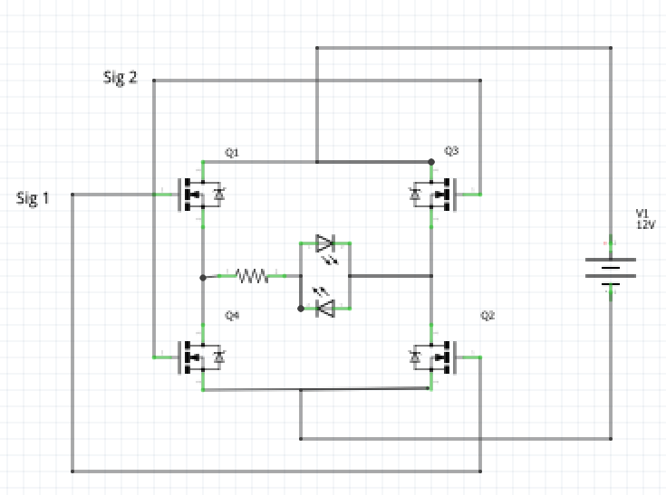
(a) (b)
Figure 6: (a) MOSFET operability check. A 10V V_{GS} input will turn on the LED if the MOSFET is operable. At a lower V_{GS}, the LED should be off. (b) Validity check of MOSFET driver and H-bridge converter. The signals 1 and 2 come from MOSFET driver. If the driver and converter is functioning correctly, the LED at top will turn on while the LED at bottom will be off if Sig 1 is high and Sig 2 is low. LED status will be inverted if Sig 1 and Sig 2 are inverted
In order to build up the whole prototype as shown in figure give, each component was tested beforehand. Without the functionality test of MOSFET and driver, it was not suitable to implement the prototype. Because, troubleshooting would be difficult. Pre-trials of apparatus are carried out as per Figure 7. After the trial, circuit connection was given which marked the end of installation process.
2.2. GUI development:
MATLAB® software was used to make an interactive environment for user to operate the H-bridge motor drive beside manual method.
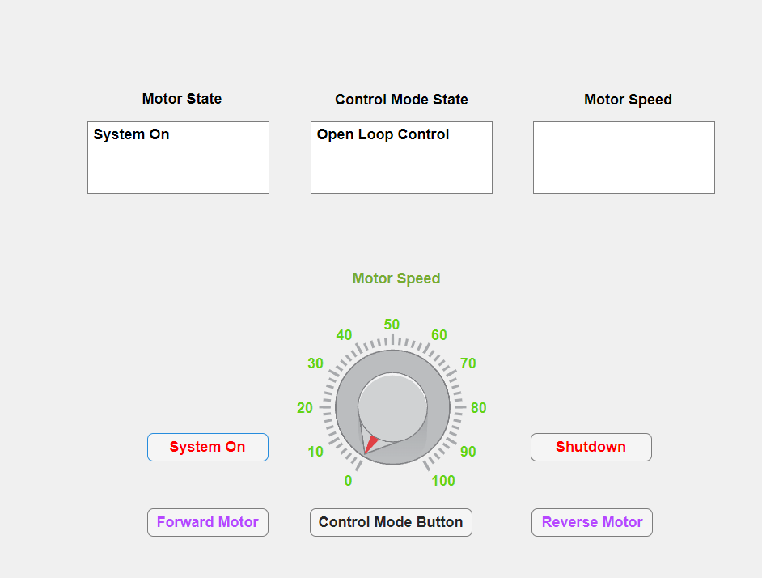
Figure 7: GUI window
This GUI display demonstrated a dial for controlling motor speed as well as few buttons whose function is textually marked (Figure 7). There were three displays namely motor state for showing motor on-off status, control mode state for showing the active speed control type and motor speed that displayed the speed of motor in rpm.

2.3. PWM Generation:
Pin no. 2 and 3 of Arduino were used to generate PWM signals. A potentiometer sensor was deployed to vary the duty cycle. Pin no. 3 governed forward rotation of motor and pin no. 2 governed reverse rotation. In the designed model, these pins are pulled to high voltage (logic level 1) and low voltage (logic level 0). MOSFET driver sensed this voltage change and commanded the MOSFET switches of H-bridge to put 12 V and 0 V across motor terminal for logic level 1 and 0 respectively. This is shown in the Figure 8. By controlling terminal voltage, speed was controlled.
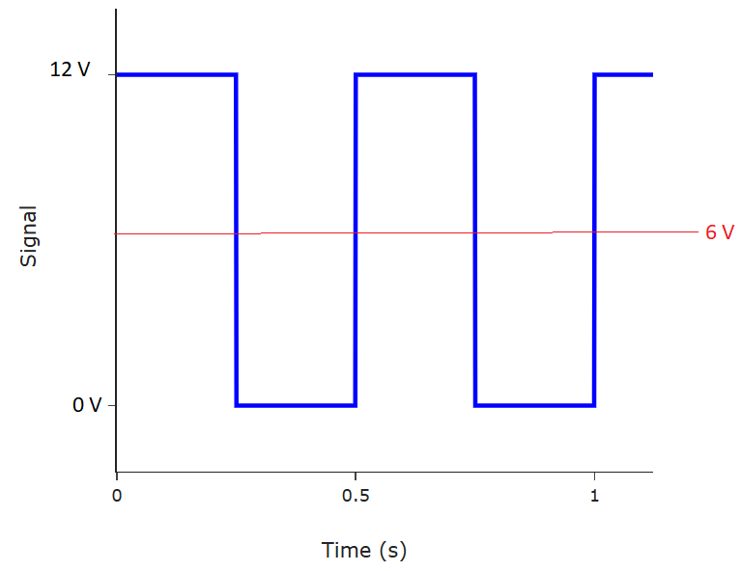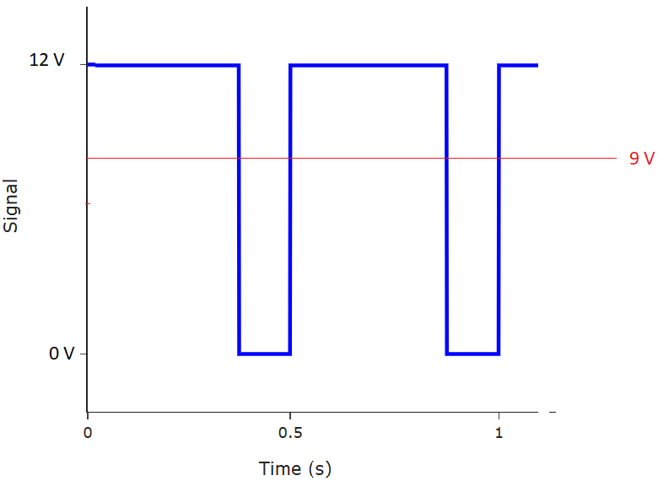
(a) (b)
Figure 8: (a) 50% duty cycle that can produce an average voltage of 6V across motor terminals. (b) 75% duty cycle that can produce an average of 9V across motor terminals.

2.4. PID Parameter Tuning:
The parameters of PID controller were $K_{p} , K_{i} and K_{d}$. They were tuned in such a way that motor speed quickly sticked to reference speed set by user and speed oscillation was minimal.
3. MODEL DESCRIPTION
3.1. Model Construction:
The motor drive designed for EV’s engine is shown in Figure 9. Components used in the project are shown in Table 1.
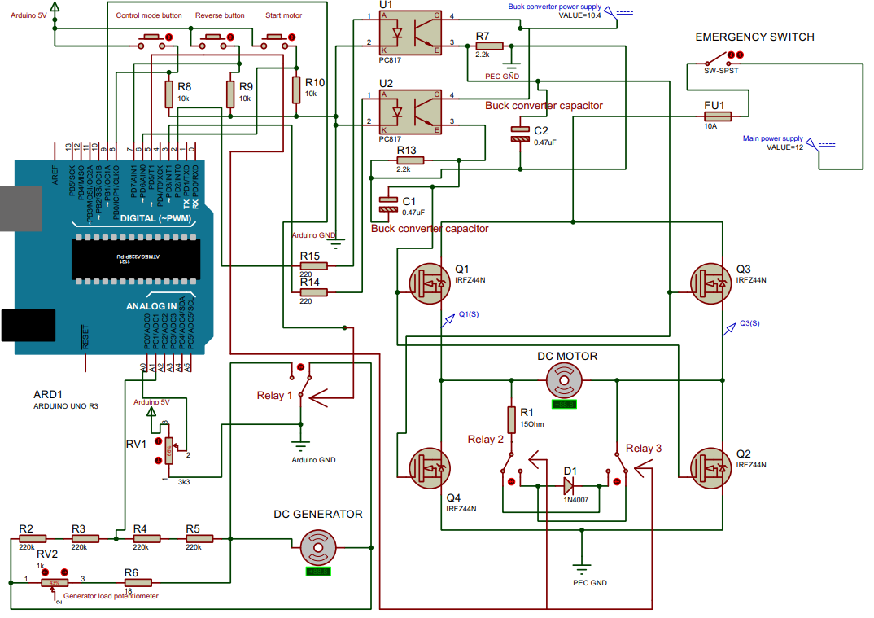
Figure 9: Circuit diagram of the whole prototype

Table 1: List of apparatus used in project
S.L No. | Name of Apparatus | Ratings | Quantity
1 | DC power supply | 11.5 V, 2 A | 1
2 | LM2596 DC-DC buck converter | V_{in} = 11.5V, V_{out} = 10.4 V | 1
3 | Arduino UNO | - | 1
4 | PC817 optocoupler | I_{F} =50mA, I_{C} =50 mA, V_{CEO} =35 V | 2
5 | IRFZ44N MOSFET |  | 4
6 | 1N4007 diode | V_{PIV} = 1000V, V_{F} = 0.7 V | 1
7 | DC motor (dynamo) | 4-12 V, 4500 rpm | 1
8 | DC generator (dynamo) | 4-12 V, 4500 rpm | 1
9 | Resistor | 220 Ω, 2.2 kΩ, 10 kΩ, 100kΩ, 0.25 W | 5 each
9 | Resistor | 15 Ω, 18Ω, 10W | 1 each
10 | Potentiometer | 1 kΩ, 100 kΩ, 1W | 1 each
11 | Relay switch | V_{trigg} = 5V | 3
12 | Rocker switch | 3A | 1
13 | Push buttons | 0.5mA | 3
14 | Fuse | 10A | 1
15 | Multimeter | 0-50V DC | 1
16 | Breadboard | - | 3
17 | Jumper wires and probes | - | As per need

Picture of project implementation are shown in the figure below:
3.2. Model Operation:
An electric vehicle requires the following operation of motor:
- Accelerating : To speed up the motor when accelerator paddle is pressed
- Braking: To slow the motor when brake paddle is pressed.
- Reverse motion: To drive reverse under reverse gear.
- Speed management: To run motor at constant speed irrespective of load given on vehicle. Weights of passengers vary so this is essential.

Transistor Q1 and Q2 were turned on by pulling up the pin no. 3 of Arduino to high logic. This helps to run motor in forward direction. On the other hand Q3 and Q4 were turned on by pulling up the pin no. 2 of Arduino to high logic and the motor rotates in reverse direction. So, logic level of pin no. 3 and 2 are complementary.
